Spatial Health Risk Assessment in Sharjah Using GIS and Automated Python-Based Weighted Overlay
Amia A. Alnaqbi^{a,∗}, Maitha A. Aldarmakiª, Anjitha S. Nairª
ªCollege of Computing and Informatics, Department of Computer Science, University of Sharjah, Sharjah, United Arab Emirates

Abstract
Environmental pollution has a significant impact on public health in rapidly growing urban areas, where emissions from industries, transportation systems, and high population density increase exposure to multiple environmental stressors. In the Emirate of Sharjah, datasets on population, industrial activity, and roads are available, but their combined effect on spatial health risk is not well represented in a single integrated framework. This study applies a GIS-based weighted overlay approach to delineate potential health risk zones in Sharjah by integrating population density, industrial activity, and road density layers. A manual weighted overlay is first implemented in ArcGIS Pro, followed by an automated workflow using a Python toolbox that reproduces the same logic programmatically. The resulting risk maps are compared in terms of spatial patterns, continuity, and consistency with known urban and industrial structures. The manual workflow produced more realistic and spatially continuous risk patterns, whereas the initial automated output showed fragmentation and parameter-sensitivity issues. The results highlight priority high-risk zones along the main urban and coastal corridor and demonstrate the value of careful layer configuration for both manual and automated GIS-based health risk assessments.
Keywords: GIS, health risk assessment, weighted overlay, Python automation, Sharjah

1. Introduction
Environmental pollution has a significant effect on public health in rapidly growing urban areas. Emissions from industries, transportation systems, and high population density increase exposure to environmental stressors. It is important to identify areas where these factors overlap to understand potential health risks. This study uses a GIS-based method to assess possible health risk zones in the Emirate of Sharjah by combining various spatial indicators through a weighted overlay technique.

2. Background and Context
Sharjah has experienced ongoing urban and industrial growth in recent decades. Industrial areas and major roads are often close to residential neighbourhoods, raising the risk of cumulative environmental exposure. High population density exacerbates this in urban and coastal regions.
GIS-based spatial modelling provides a solid framework for merging environmental and demographic factors into a single spatial index. Weighted overlay analysis is commonly used to show the combined influence of different risk components within one mapped surface.

3. Problem Statement
Although data on population density, industrial activity, and road networks in Sharjah are available separately, their combined effect on potential health risk is not clearly represented within a single integrated framework. The absence of such an assessment limits the ability to identify areas that may require priority monitoring and comparison.
This study addresses this gap by applying a GIS-based weighted overlay model to integrate population density, industrial activity, and road density in order to delineate potential health risk zones across Sharjah. As a result, differences in environmental pressure between neighbourhoods can be better understood by considering the combined influence of multiple exposure factors rather than individual layers alone.

4. Study Area
The study area is the Emirate of Sharjah in the United Arab Emirates. It includes densely populated urban centres, large industrial zones, extensive transportation networks, and sparsely populated interior regions. The spatial extent of the study area is consistently represented across all datasets used in this analysis.

5. Methodology

5.1. Data Sources
Three main datasets were used in this study. Population density data were taken from the WorldPop 2022 dataset, which provides gridded population information suitable for spatial analysis. Industrial land-use data were obtained from Sharjah Municipality planning layers, which include polygon features representing industrial zones in the emirate.Road network data were collected from the ArcGIS Living Atlas, which provides updated and verified road layers compatible with ArcGIS Pro.Before starting the analysis, all datasets were clipped to the Sharjah boundary and standardized to the same coordinate reference system to ensure that they aligned correctly during processing

.5.2. Pre-processing and Geodatabase Preparation
All datasets were clipped to the administrative boundary of Sharjah and projected to a unified coordinate system to ensure spatial consistency. The data were organised within a single geodatabase to support efficient processing and minimise spatial misalignment.

5.3. Manual Weighted Overlay Process
The manual analysis was completed in ArcGIS Pro and involved preparing the datasets, converting them into raster format, and combining them to produce one final health-risk raster using a weighted overlay.
First, the population, industry, and road datasets were clipped to the Sharjah boundary. All layers were then prepared to ensure proper spatial alignment before starting the raster-based processing steps.
Second, the industry and road datasets were originally in vector format, so they were converted to raster using the Feature to Raster tool. This conversion ensured that all layers shared the same structure and could be used together in pixel-based calculations.
Third, each raster dataset was reclassified into three classes representing low, medium, and high levels of potential health risk. This standardization placed all layers on the same scale and allowed them to be evaluated within one analysis framework.
Fourth, weights were assigned to the three layers based on their influence on health-risk conditions. Industrial areas received the highest weight because they represent major pollution sources. Roads were given a moderate weight to represent emissions from traffic, and population density received the lowest weight since it mainly reflects exposure. The weights used in this study were:
Industry: 0.5
Roads: 0.3
Population: 0.2
The weighted health-risk raster was then generated using Raster Calculator according to the following equation:
HRI = (Ir × 0.5) + (Rr × 0.3) + (Pr × 0.2)
where Ir, Rr, and Pr represent the reclassified industry, road, and population rasters. This produced a continuous surface showing how the three factors interact spatially across Sharjah.
Finally, the output raster was reclassified into moderate- and high-risk categories. The high-risk class was extracted as a separate layer to clearly highlight areas where industrial activity, road proximity, and population density overlap at higher levels.
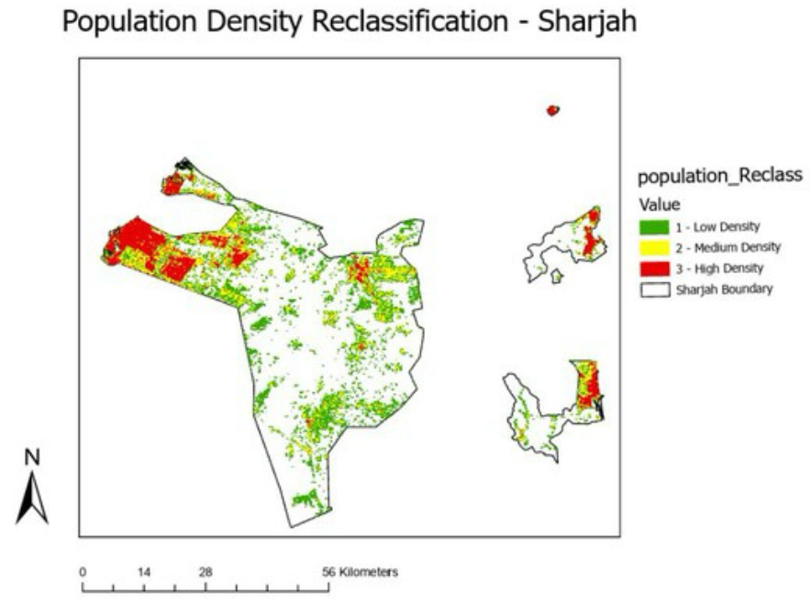
.

Figure 1. Reclassified population density map of Sharjah. This figure shows population exposure levels used as input in the weighted overlay analysis.

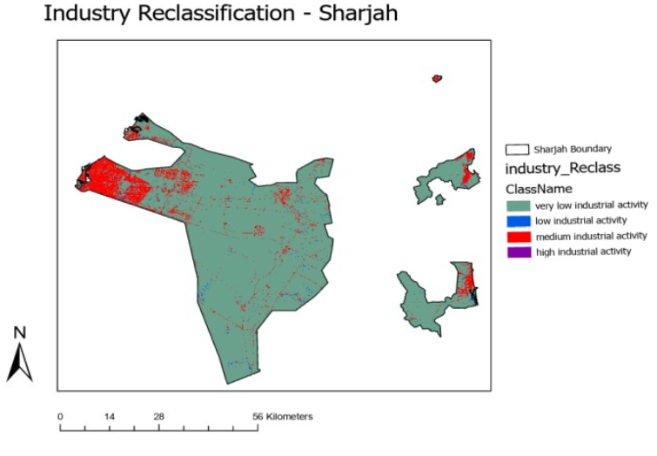
Figure 2. Reclassified industrial activity map of Sharjah. Industrial zones are classified by their potential contributions to environmental pollution.

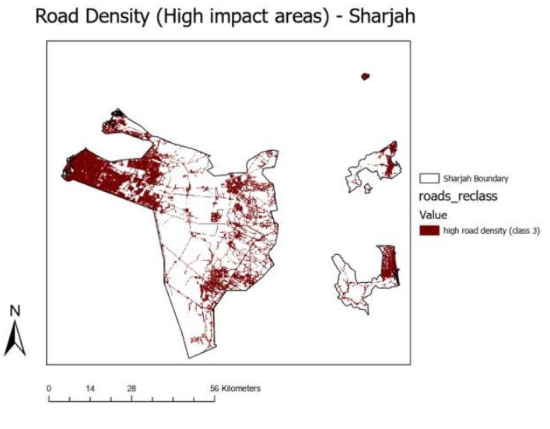

Figure 3. Road density map highlighting high-impacttransportation corridors. This layer shows traffic-related pollution influences across the studyarea.

5.4. Automated Python-Based Weighted Overlay Process
The automated workflow was developed to repeat the manual overlay steps without doing each map separately. A Python script was written in ArcGIS Pro so that the software handles the conversion, reclassification, weighting, and overlay in one run. The idea is that instead of manually applying tools several times, the script performs the same logic faster and in a more consistent way.

The code first checks that the required layers are available and sets the workspace. It then converts the vector layers into raster format and assigns values based on their influence on health risk. After conversion, each layer is normalised so they can be combined fairly. The weighted overlay step sums the inputs based on their assigned importance, creating one output layer that reflects the combined risk.

Once the final raster is created, the script automatically classifies the result into readable categories, which help interpret areas with higher or lower risk. This automation reduces user error, saves processing time, and allows the method to be repeated in future studies without rebuilding the workflow each time.

6. Manual Risk Map

The manual weighted overlay analysis created a composite health risk map for Sharjah. The output integrates population exposure, industrial activity, and road density to pinpoint areas of potential health concern. The composite index was then reclassified into risk categories, and the high-risk class was extracted as a separate layer to highlight priority zones.

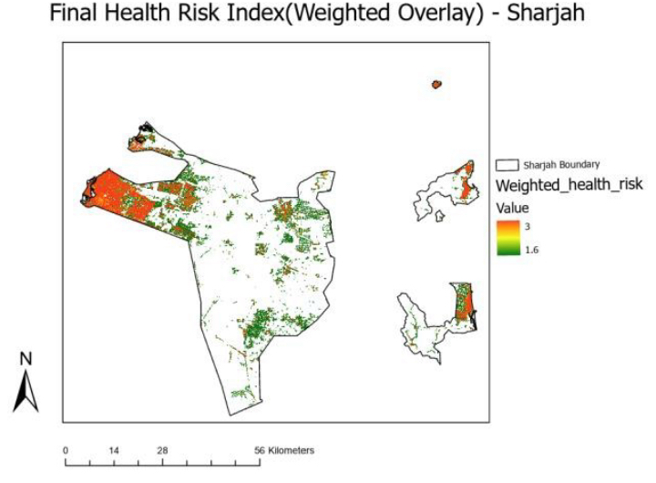
Figure 4. Manual health risk index map generated from weighted overlay analysis.
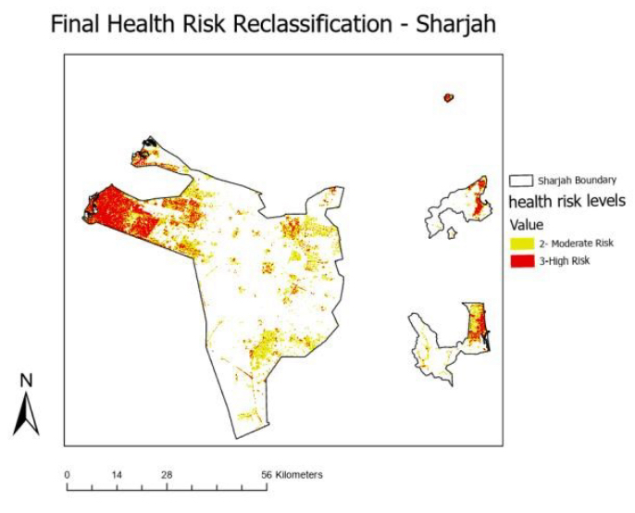
Figure 5. Final reclassified manual health risk map showing risk categories.

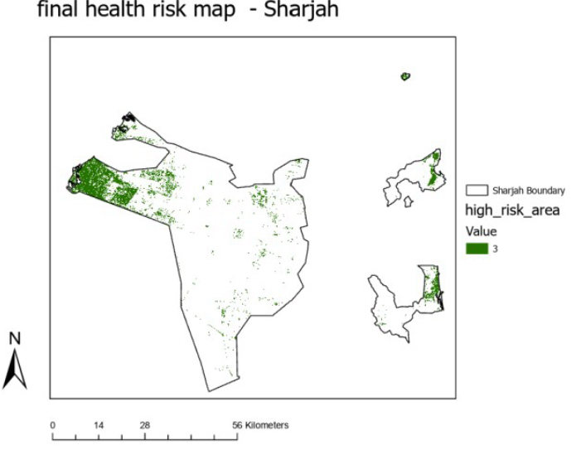
Figure 6. Extracted high-risk zones identified from the manual health risk map.

7. Automated Python-Based Weighted Overlay

7.1 Script-Based Workflow
The automated map was created through a Python toolbox developed for this study. Instead of executing each step by hand, the script follows the same logical workflow but performs it automatically. Once the tool is run, it reads the input layers, converts them if needed, applies the weights, and produces the final layer without additional manual effort. This approach
makes the process faster and reduces small mistakes that usually happen
during repeated manual work.

7.2 Final Automated Output
The automated tool produced one combined risk map for Sharjah. Unlike
the manual approach, where separate maps were generated for each factor
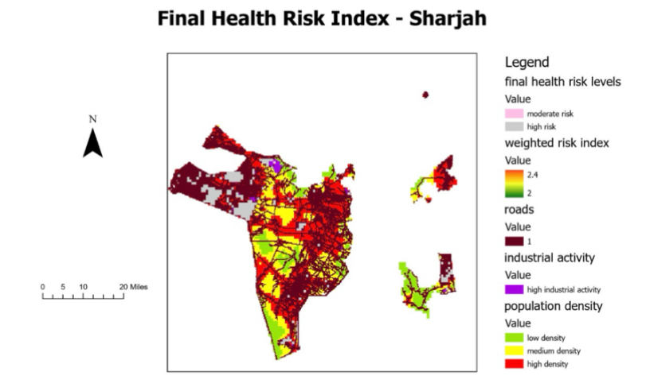

Figure 7. Final automated health risk index map for Sharjah.
This composite surface displays the combined influence of population density, road density, and industrial activity, highlighting spatial clusters of elevated exposure risk.

7.3 Spatial Patterns & Insights
When looking at the automated output, the distribution made sense compared to how Sharjah is built. Dense areas with traffic, industries, and housing showed higher risk levels, while places farther from those activities appeared less stressed. Because the
tool generated everything at once, the final surface looked cleaner than manually stacking maps. It helped us see the variations more clearly and confirmed that automation can support better interpretation.

8. Comparison & Interpretation

8.1 Manual vs. Python Outputs

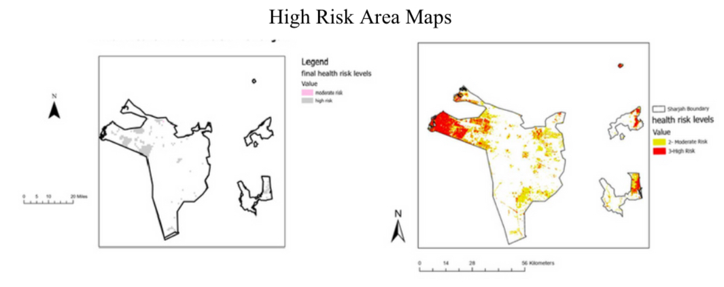
The main health risk factors in Sharjah such as industrial activity, dense road networks and high population, are all grouped along the main city and coastal corridor. Industrial areas and major highways, especially near the Sharjah-Dubai border form a concentrated area of economic activity and vehicle emissions as shown by industrial and road density maps. The figure 4 health risk map clearly shows this pattern with high-risk areas matching the places
with the most industry and roads. This clustered view comes from combining risk factors in a way that gives a realistic picture of overall health risk. On the other hand the figure 3 map shows risk as scattered isolated spots that do not match the real distribution of these factors. Therefore, the figure 4 map offers a more accurate and logical depiction of health risk in Sharjah while the figure 3 map misses the alignment and does not reflect the true spatial reality

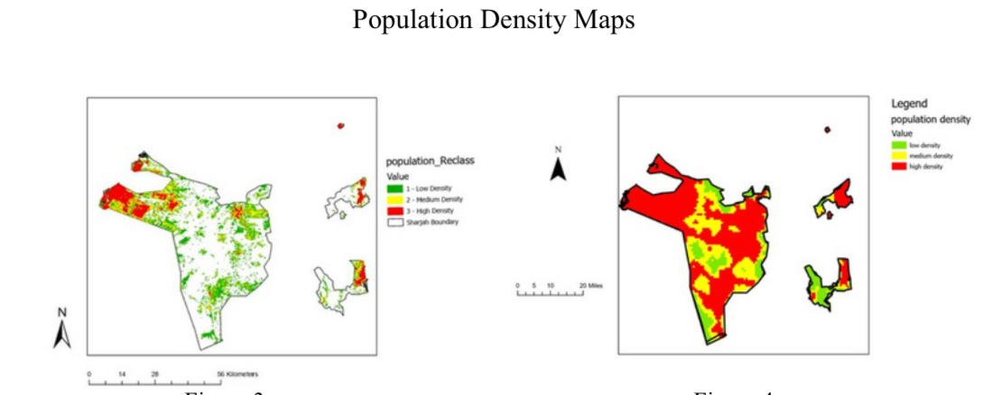
Both the (Manual) and (Python) maps depict population density in Sharjah. They are using green, yellow used for medium and red to represent high population density in Sharjah. The figure 1=3 map shows that most of the area is sparsely populated or uninhabited with the population concentrated in small, isolated clusters particularly close to urban centres. The
map on the other hand, displays sizable, continuous blocks of density, indicating extensive, consistent population coverage throughout almost the whole area.

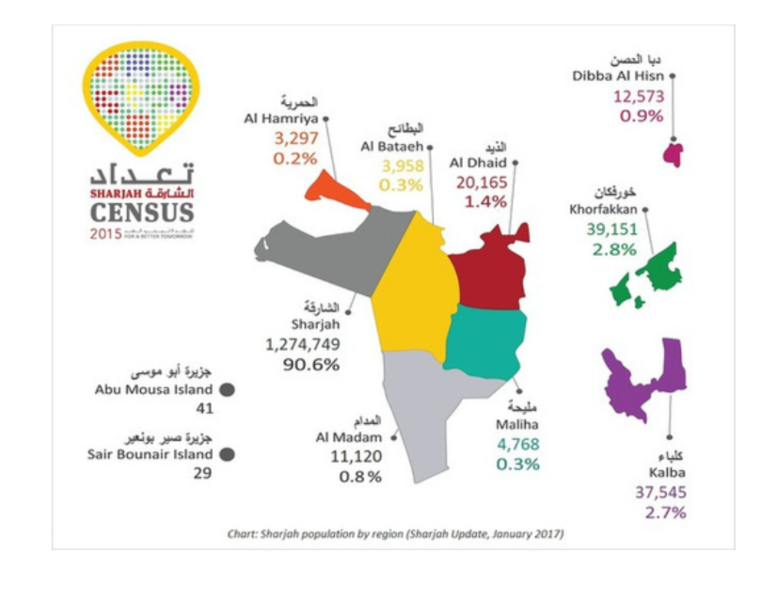
With 91% of the population residing in Sharjah city and only a small percentage in other cities like Khorfakkan, Kalba, and Al Dhaid a closer examination of Sharjah's 2015 census data confirms a highly uneven population distribution. Any accurate map should depict the vast sparsely populated or uninhabited areas that make up the majority of the emirate.
The figure 3 map closely matches the census data showing low or unclassified density throughout the majority of the interior and only high density clusters in major urban areas particularly Sharjah city and the East Coast enclaves. The figure 4 map on the other hand does not reflect the actual demographic pattern and exaggerates population spread by displaying large, neighbouring zones of moderate and high density across much of the territory. Thus, the figure map accurately depicts both the concentration of people in urban centres and the absence of people elsewhere. While figure 4 map overstates and dilutes the true distribution because of coarse processing or inappropriate parameters.
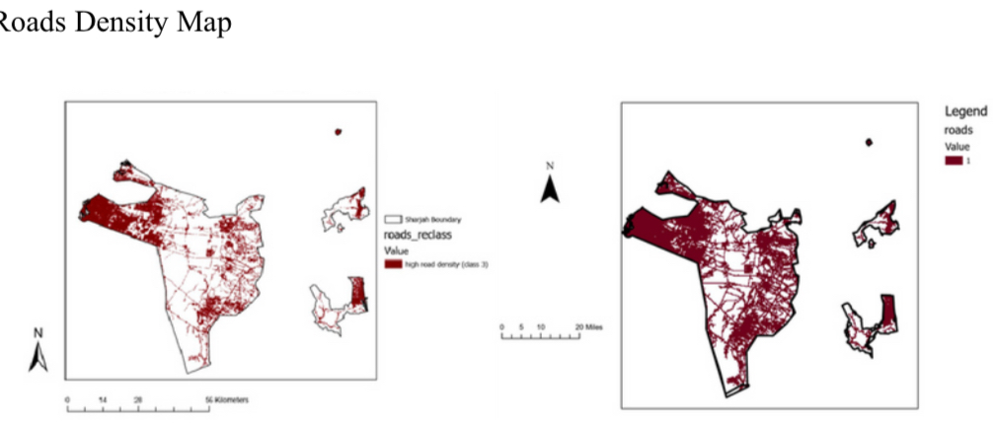
.

This shows the physical locations of roads as vector lines, while displays a raster surface to represent the concentration and influence of roads across an area. The density map captures how vehicle emissions disperse beyond individual road lines, modeling their regional impact and cumulative effect on air quality. Using road density is essential for environmental risk analysis because it realistically reflects how pollution spreads and accumulates in areas with dense road networks.
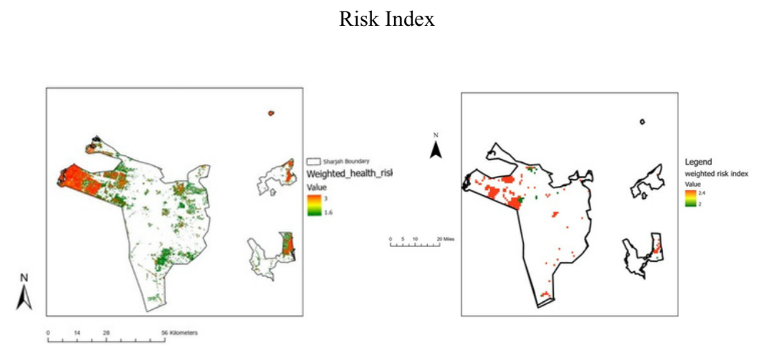
The figure 7(Manual) map is notable for its distinct spatial trends and broad value range (1.6 to 3). It shows a clear continuous high risk zone in urban areas and along the coast with high risk areas precisely matching road, industrial and population densities. Planners and decision makers will find this dynamic and actionable visualisation to be a realistic and helpful tool as it accurately depicts the cumulative impact of multiple risk factors. The figure 8(Python) on the other hand has a fragmented spatial pattern with isolated high risk patches and huge unclassified areas as well as a narrow value range (2 to 2.4). True risk zones are under represented maybe due to problems with weighting classification or spatial aggregation as indicated by the lack of spatial continuity and muted colour spectrum.

8.2 Differences and Consistency
Both the automated and manual processes followed the same basic logic of merging weighted and reclassified layers. The efficiency and final visual output however differed noticeably.
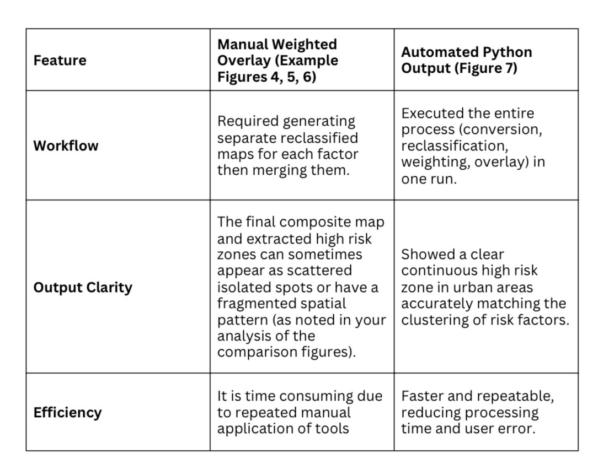

8.3 Accuracy & Reliability Discussion
The analysis showed that while the configuration used to create the Python compared map (Figure 4) exaggerated the population spread the underlying input layer configurations of the Manual Map (Figure 3 Population Density) accurately reflected known population characteristics. This suggests that, in comparison to the manual approach, the parameters or techniques selected for the automated classification and conversion stages of the Python script were less effective in capturing the spatial depth of the input data. A better representation of the cumulative environmental influence which is expected to spread over continuous areas was given by the Manual Map's (Figure 7) strong spatial continuity and wide value range. On the other hand possible problems with weighting, classification or spatial aggregation within the automated workflow were suggested by the fragmented pattern of the Python output (Figure 8). The manual workflow produced the most accurate and dependable spatial patterns for defining the high risk zones that correspond with Sharjah's established industrial, road and population distribution even though the Python script is perfect for reproducibility and cutting down on processing time.

9. Conclusion and Recommendations

This study integrated three major spatial stressors—road density, indus- trial activity, and population density—using a GIS-based weighted overlay model to identify possible health risk zones throughout the Emirate of Shar-
jah. The combined index clearly identifies high-risk zones concentrated along the main urban and coastal corridor, corresponding to significant industrial areas and dense road networks. Spatial comparisons showed that, compared to the initial outputs produced by the automated Python script, the manual weighted overlay maps consistently provided a more accurate, realistic, and spatially continuous representation of health risk. This indicates that manual configuration of input parameters currently captures the spatial reality more effectively.

Recommendations
• Refine the Python script parameters, particularly those controlling reclassification, raster conversion, and aggregation, and test them thoroughly to ensure that the automated output matches the spatial accu-
racy of the manual maps.
• Prioritise environmental monitoring and public health resource allocation in designated high-risk zones close to industrial areas and busy roads.
• Perform a sensitivity analysis on the weighting factors to verify their impact and ensure that the significant contribution of industrial areas is appropriately represented.
• In future stages, integrate additional environmental stressors such as real air-quality measurements or detailed land-use data to further improve the model’s predictive power.

9.References

@miscESRI2023, author = ESRI Living Atlas, year = 2023, title =
Environmental and infrastructure datasets, howpublished = https:
//livingatlas.arcgis.com @miscSharjah2023, author = Sharjah
Municipality Open Data, year = 2023, title = Administrative bound-
aries and infrastructure datasets, institution = Government of Shar-
jah @miscWorldPop2022, author = WorldPop, year = 2022, title
= Global High-Resolution Population Density Maps, howpublished =
https://www.worldpop.org @bookWHO2021, author = World Health
Organization, year = 2021, title = Air Quality Guidelines: Global
Health Recommendations, publisher = WHO Press @articleXu2013,
author = Xu, H., year = 2013, title = GIS-based environmental pollu-
tion assessment, journal = Environmental Monitoring and Assessment,
volume = 185, number = 4, pages = 2975–2983, doi = 10.1007/s10661-
012-2750-0

